Sumit Vadaviya

Camunda BPM Expert, Corporate Trainer

Email : sumit.vadaviya@trainosoft.com

I

n this session we will configure camunda modeler plugin with Eclipse IDE.

# **1. Software required**

`Camunda Modeler Eclipse Plugin Installation

Eclipse Java EE IDE for Web Developers.

Version: Photon Release (4.8.0)

Build id: 20180619-1200

# **2. Installing Modeler Plugin**

Open eclipse and navigate to Menu Help Install New Software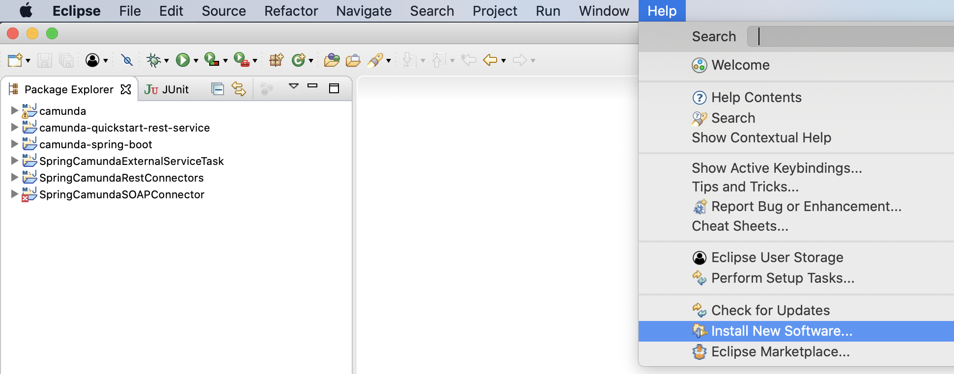

Enter Camunda modeler plugin URL <http://camunda.org/release/camunda-eclipse-plugin/update-sites/kepler/archive/2.7.1/> and hit the Add button.

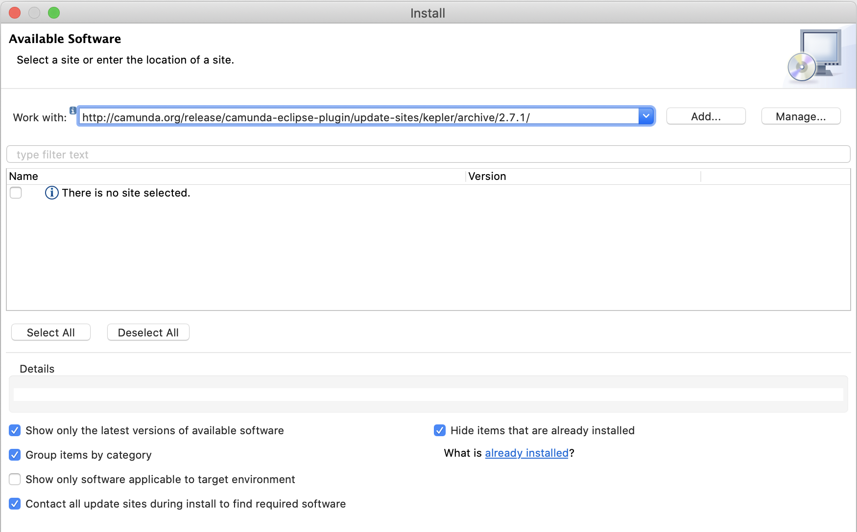

# Add Repository.

# Hit OK button

# Check the Camunda BPM modeler.

# Hit the Next button.

# Hit the Next button.

# Accept the terms and license agreement.

Hit the Finish button. Plugin installation will start.

Ignore the security warning and hit the Install anyway button.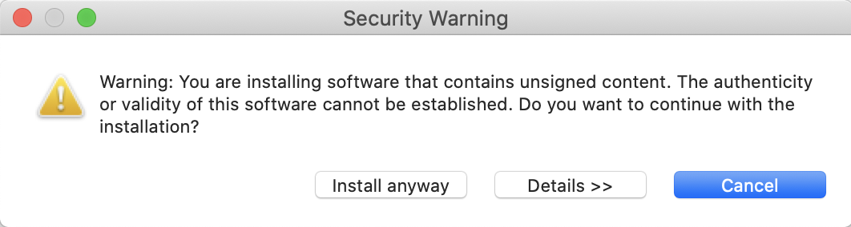

Then you will be asked to restart eclipse for the changes to take effect.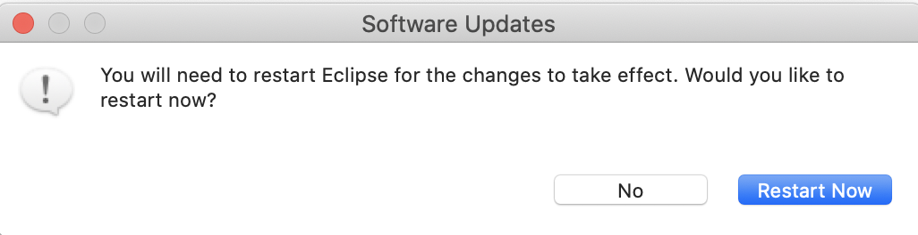

Hit the Restart Now.

# Verify installation.